**Setting environment for using XAMPP for Windows:** mysql -u root -p

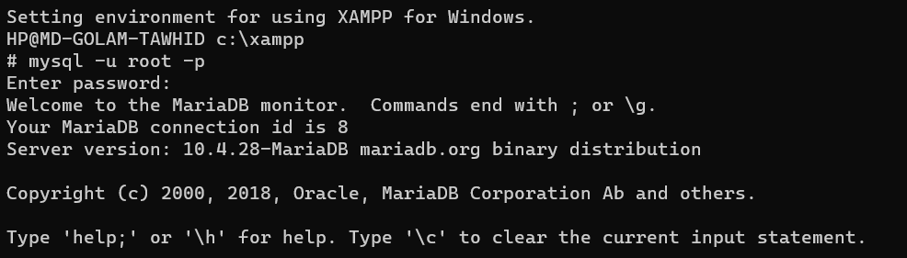

**Showing databases:** show databases;

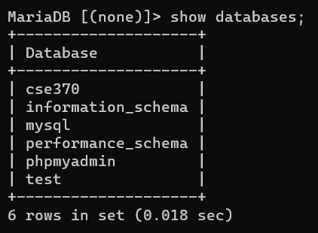

**Showing tables:** show tables;

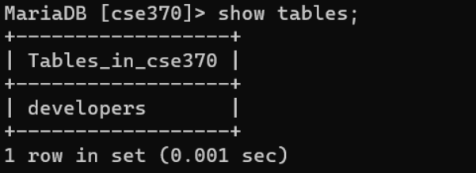

**Creating tables and Inserting data:**

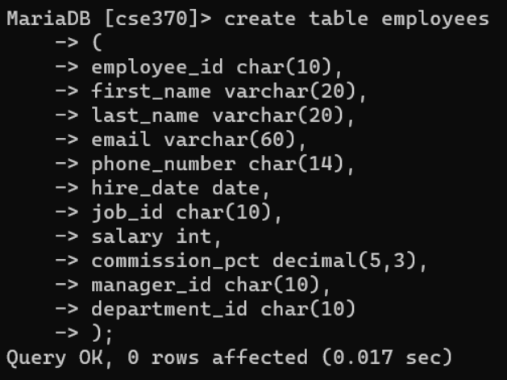

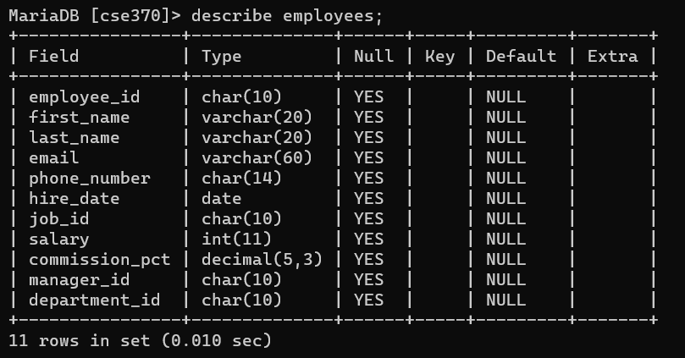

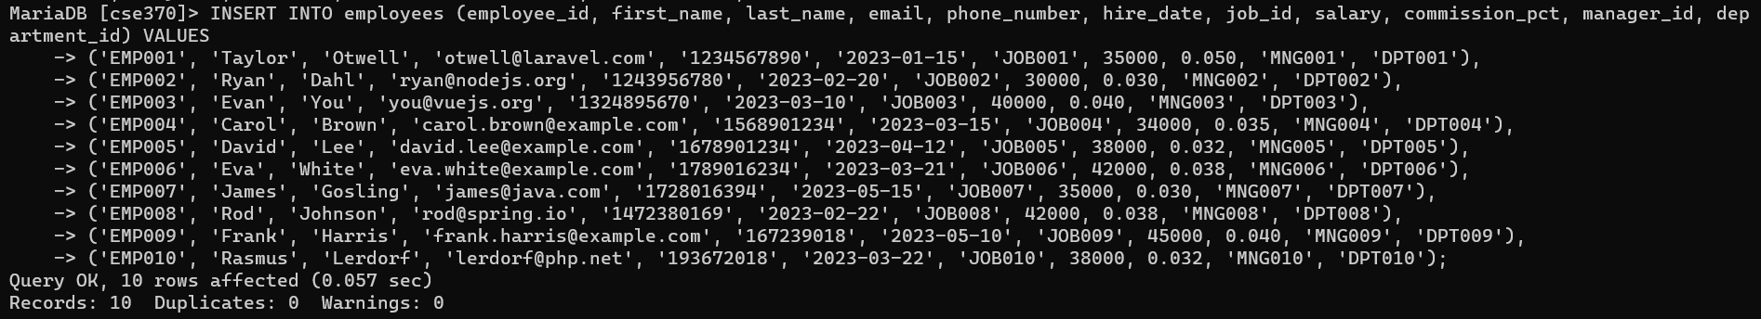

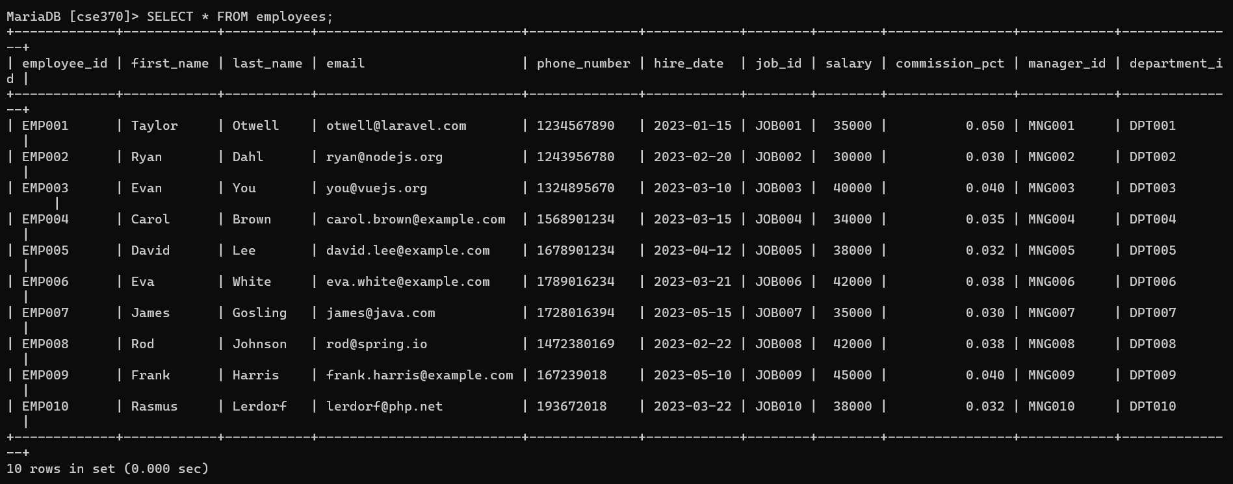

**TASK 1:** SELECT first_name, last_name, email, phone_number, hire_date, department_id

-> FROM employees

-> WHERE hire_date = (SELECT MAX(hire_date) FROM employees);

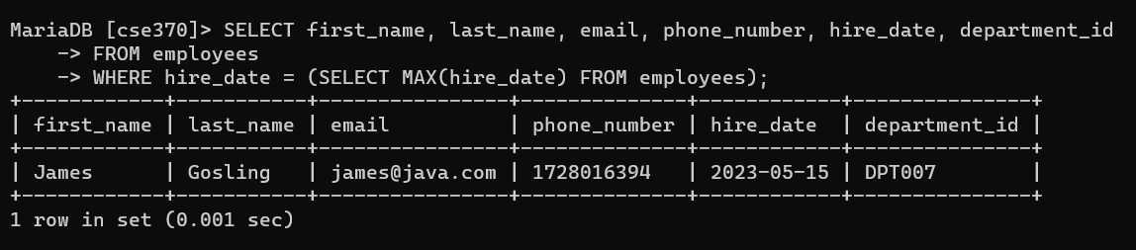

**TASK 2:** SELECT first_name, last_name, employee_id, phone_number, salary, department_id

-> FROM employees

-> WHERE (department_id, salary) IN

-> (SELECT department_id, MIN(salary)

-> FROM employees

-> GROUP BY department_id

-> );

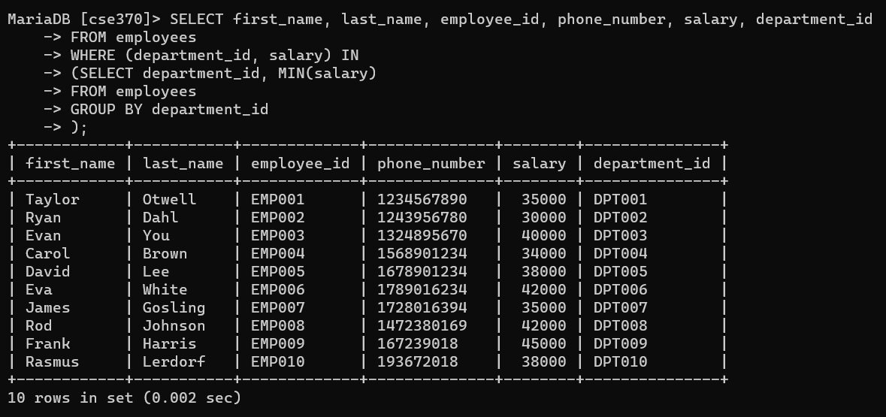

**TASK 3:** SELECT first_name, last_name, employee_id, commission_pct, department_id

-> FROM employees

-> WHERE department_id = "DPT007"

-> AND commission_pct < ALL

-> (SELECT commission_pct

-> FROM employees

-> WHERE department_id = "DPT005"

-> );

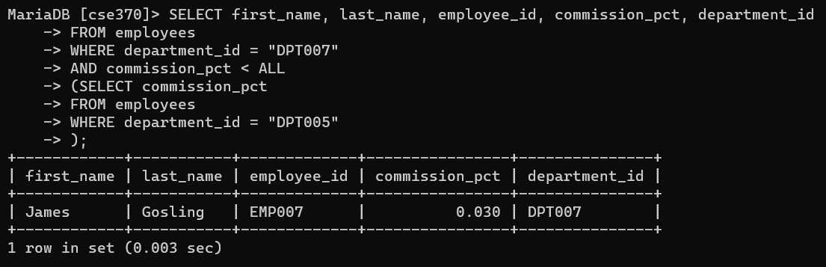

**TASK 4:** SELECT department_id, COUNT(*) AS total_employees

-> FROM employees

-> GROUP BY department_id

-> HAVING MAX(salary) <= 30000;

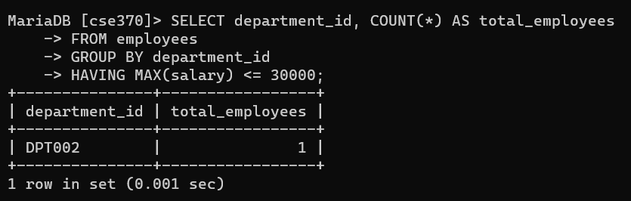

**TASK 5:** SELECT e.department_id, e.job_id, e.commission_pct

-> FROM employees e

-> WHERE e.commission_pct < ANY

-> (SELECT commission_pct

-> FROM employees

-> WHERE department_id = e.department_id

-> AND job_id != e.job_id

-> );

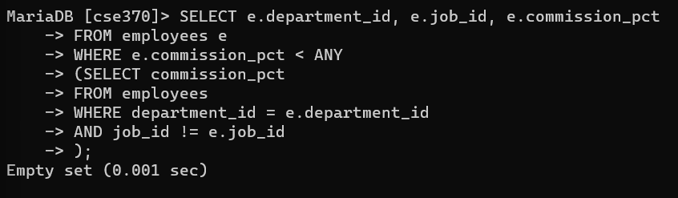

**TASK 6:** SELECT DISTINCT manager_id

-> FROM employees

-> WHERE NOT EXISTS

-> (SELECT 1 FROM employees

-> WHERE manager_id = employees.manager_id

-> AND salary < 3500

-> );

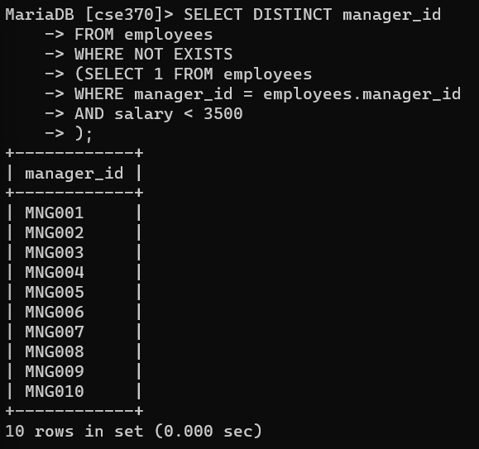

**TASK 7:** SELECT e.first_name, e.last_name, e.employee_id, e.email, e.salary, e.department_id, e.commission_pct

-> FROM employees e

-> WHERE (e.commission_pct, manager_id) IN

-> (SELECT MIN(commission_pct), manager_id

-> FROM employees

-> GROUP BY manager_id

-> );

